 BWYDLEN PLANT  
CHILDREN’S MENU

**All Main Dishes are £8.50**

Fish Goujons, Fries, Mushy Peas

Chicken Pieces, Fries & Beans

Sausage, Mash, Peas & Gravy

(V) 6” Margherita Pizza

(V) Tomato Tagliatelle & Garlic Bread

Drinks

Fruit Shoot (200ml) £2.30  
Orange juice (200ml) £2.80

Apple juice (250ml) £3.50  
½ Lemonade £2.20

½ Diet Pepsi £2.20

½ Pepsi £2.40  
J20 (275ml) £3.50  
Milk £2.50

* VEGETABLES OR SALAD

CAN BE TAKEN INSTEAD OF CHIPS

Milkshakes – £4.50

Deluxe Strawberry   
cream, marshmallows & sprinkles

Deluxe Chocolate

Cream, chocolate flake & sprinkles

Deluxe Banana

Cream, banana chips & sprinkles

Dessert

Warm Chocolate Brownie £6.00  
vanilla ice cream

Natural Yoghurt, fruit compote £4.00

Sticky Toffee Pudding £6.00

vanilla ice cream

Ice Cream Parlour Pick ‘n’ Mix £7.00

vanilla & strawberry ice cream with sides of chocolate sauce, sprinkles, fudge pieces & marshmallows to build your own sundae

**FOOD ALLERGIES & INTOLERANCES**

**Please inform your server of any allergen or intolerance before placing your order for food and/or drink. Our full Allergen Information Booklet is available upon request. All dishes are prepared in areas where allergens are present. Therefore, there is a risk that ingredients used in your meal may have come into contact with an undeclared allergen, leading to cross contamination. Cooking equipment (e.g., fryers, grills etc) and food preparation areas may be shared, with fried items containing different allergens cooked in the same frying oil.**

Suitable for children aged 13 and under

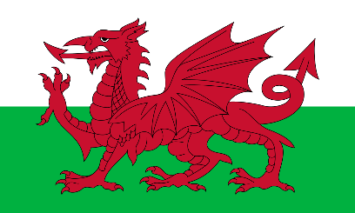

**Y Ddraig Goch, meaning the ‘The Red Dragon’**

To colour Y Ddraig Goch, colour the bottom half of the flag green, the dragon red and leave the top half white.