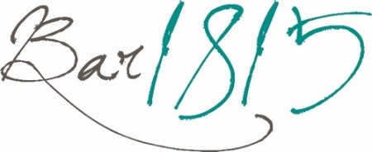
10am-3pm Tues-Fri
10am-5pm Sat & Sun
Breakfast Baps
(available 10am-12pm)

Bacon & Fferm Ochr Cefn Isa Egg £8.50

Sausage & Fferm Ochr Cefn Isa Egg £8.50

Add bacon £1.50
Add sausage £1.50

Sandwiches
Served on white or granary bread and available toasted
All served with a salad garnish, coleslaw & crisps

Welsh Rarebit £9.50
served on bloomer bread with bacon £11.00

Southern Fried Chicken £11.50
chipotle sauce, lettuce

Warm O.E Metcalfe Roast Beef £11.50
onion marmalade

Honey Roasted Ham & Welsh Cheddar £10.50
apple chutney, lettuce, tomato

Battered Cod Goujons £11.50
tartare sauce, lettuce

(VG) Breaded Aubergine £10.50
tomato jam, lettuce

Add a bowl of Soup of the Day £4.00

------------------------------------------------------------------------------------- -----------------------------------------------------------------

Light Bites
Farmhouse Salad £16.00
Cheddar & onion quiche, ham, Welsh Cheddar, apple chutney, coleslaw, house salad, buttered bloomer

Buttermilk Fried Chicken £12.75
Nduja waffle, poached egg, chili cheese sauce,
house salad

King Prawn Tagliatelle £14.95
Pan fried King Prawns in white wine, lemon, garlic, tomato & parsley tagliatelle

Haddock Fishcake £14.95
Skinny fries, house salad, tartare sauce

Pizzas

The Classic (V) £13.00
Tomato base, mozzarella, oregano
The Bridge Special £16.50
Tomato base, chilli beef, red onion, jalapeno, mozzarella
The Farmhouse £16.00
Tomato base, ham, mushroom, mozzarella
The Smoky £16.50
Tomato base, nduja, pepperoni, mozzarella, hot honey
The Vegan (VG) £15.50
Tomato base, vegan cheese, tomato, peppers
The Goat (V) £15.50
Tomato base, goats’ cheese, red onion, mozzarella

------------------------------------------------------------------------------------- -----------------------------------------------------------------

Side Orders

Hand cut chips £5.00

Skinny fries £4.50

Onion Rings £4.00

Side Salad £4.00

Garlic Bread £4.50

Cheesy Garlic Bread £5.50

Additional Toppings
Ham £2.50 Mushrooms £1.50
Pepperoni £2.50 Welsh Cheddar £2.00
Chilli Beef £3.00 Goats Cheese £2.00
Olives £2.00 Stilton Blue Cheese £2.50
Jalapenos £1.50 Red Onion Marmalade £1.50

FOOD ALLERGIES & INTOLERANCES
Please inform your served of any allergen or intolerance before placing your order or food and/or drink. Our full allergen information booklet is available on request. All dishes are prepared in areas where allergens are present. Therefore, there is a risk that ingredients used in your meal may have come into contact with an undeclared allergen, leading to cross contamination. Cooking equipment (e.g. fryers, grills etc) and food preparation areas may be shared, with fried items containing different allergens cooked in the same frying oil.

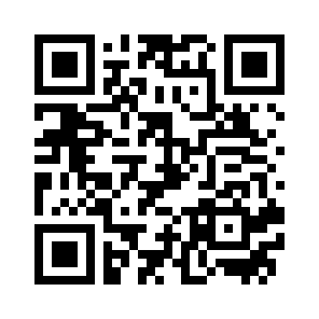
Please scan the QR code for full allergen and ingredient information

Iced Coffee £3.60

shot of espresso poured over ice with milk

Add whipped cream +50p
Cakes

Traditional Fruit Scone £3.75
with jam & cream

The Bridge Flapjack £2.95

Bara Brith £3.50
traditional Welsh fruit bread served with butter

(GF)Homemade Chocolate Brownie £3.95

Coffee Syrups +50p

Caramel
Vanilla
Pumpkin Spice
Speculoos (Biscoff)
Milkshakes

Deluxe Strawberry £4.50
cream, marshmallows & sprinkles

Deluxe Chocolate £4.50
cream, chocolate flake & sprinkles

Deluxe Banana £4.50
cream, banana chips & sprinkles

Deluxe Biscoff £4.50
cream, caramel sauce & biscuit

Deluxe Mint Choc £4.50
cream, choc chips & sprinkles
Hot Drinks
Regular Large
Pot of tea for one £2.90

Speciality Tea for one £3.10

Espresso £2.90

Double Espresso £3.65

Latte £3.75 £4.75

Americano £3.20 £4.20

Cappuccino £3.75 £4.75

Hot Chocolate £3.75

The Bridge Luxury Hot Chocolate £4.75
cream, marshmallows & flake

Please scan the QR code for full allergen and ingredient information

FOOD ALLERGIES & INTOLERANCES
Please inform your served of any allergen or intolerance before placing your order or food and/or drink. Our full allergen information booklet is available on request. All dishes are prepared in areas where allergens are present. Therefore, there is a risk that ingredients used in your meal may have come into contact with an undeclared allergen, leading to cross contamination. Cooking equipment (e.g. fryers, grills etc) and food preparation areas may be shared, with fried items containing different allergens cooked in the same frying oil.

------------------------------------------------------------------------------------- -----------------------------------------------------------------
10am-3pm Tues-Fri
10am-5pm Sat & Sun

