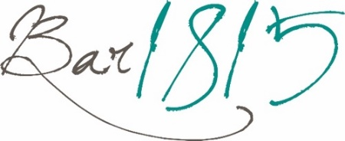
10am-5pm Saturday
10am-3pm Wednesday - Sunday
Breakfast Baps/Baps Brecwast
(available 10am-3pm)

Bacon & Fferm Ochr Cefn Isa Egg £8.50

Sausage & Fferm Ochr Cefn Isa Egg £8.50

Add bacon £1.50
Add sausage £1.50

Sandwiches/Brechdanau
Served on white or granary bread and available toasted
All served with a salad garnish and coleslaw

Southern Fried Chicken £11.50
bacon maple jam

Warm O.E Metcalfe Roast Beef £11.50
mustard mayonnaise

Honey Roasted Ham & Tomato £10.50

Welsh Cheddar Cheese & Red Onion £10.50

Open Bloomer Sandwiches
Served on white or granary bloomer
All served with a salad garnish and coleslaw

Welsh Rarebit £10.50
with bacon £12.00
Fferm Ochr Cefn Isa Egg Mayo £10.50

Prawn & Marie Rose Sauce £10.50

------------------------------------------------------------------------------------- -----------------------------------------------------------------

Salad

The Ploughman’s £16.00
Honey Roasted Ham, Welsh Cheddar, apple chutney, coleslaw, house salad, buttered bloomer

Homemade Haddock Fishcakes £14.95
house salad, coleslaw, tartar sauce

Cheddar & Onion Quiche £16.00
house salad, coleslaw, buttered potatoes

Pizzas

The Classic (V) £13.00
Tomato base, mozzarella, oregano
The Bridge Special £16.50
Tomato base, chilli beef, red onion, jalapeno, mozzarella
The Aloha £15.50
Tomato base, ham, pineapple, mozzarella
The Smoky £16.50
Tomato base, nduja, pepperoni, mozzarella, hot honey
The Goat (V) £15.50
Tomato base, goats’ cheese, red onion, mozzarella

------------------------------------------------------------------------------------- -----------------------------------------------------------------
Side Orders/Yn Ychwanegol

Hand Cut Chips £5.00

Skinny fries £4.50

Side Salad £4.00

Garlic Bread £4.50

Cheesy Garlic Bread £5.50

Loaded Fries/Sglodion Llwythog

Small £8.75 or Large £14.00

Chilli Beef
Chili jam, chipotle sauce, cheese & crispy onions

Buttermilk Fried Chicken
Chili jam, chipotle sauce, cheese & crispy onions

Southern Fried Halloumi
Chili jam, chipotle sauce, cheese & crispy onions

Additional Toppings/Yn Ychwanegol
Ham £2.50 Mushrooms £2.00
Pepperoni £2.50 Welsh Cheddar £2.50
Chilli Beef £3.00 Goats Cheese £2.50
Olives £2.00 Stilton Blue Cheese £2.50
Jalapenos £2.00 Red Onion Marmalade £2.00

FOOD ALLERGIES & INTOLERANCES
Please inform your served of any allergen or intolerance before placing your order or food and/or drink. Our full allergen information booklet is available on request. All dishes are prepared in areas where allergens are present. Therefore, there is a risk that ingredients used in your meal may have come into contact with an undeclared allergen, leading to cross contamination. Cooking equipment (e.g. fryers, grills etc) and food preparation areas may be shared, with fried items containing different allergens cooked in the same frying oil.

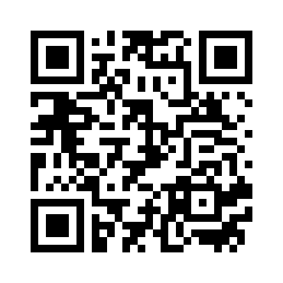

Please scan the QR code for full allergen and ingredient information

Iced Coffee/Coffi wedi’i Rhewi £3.75

shot of espresso poured over ice with milk

Coffee Syrups 50p

Caramel
Vanilla
Pumpkin Spice
Speculoos (Biscoff)
Hazelnut
Hot Drinks/Diodydd Poeth
Regular Large
Pot of tea for one £2.90

Speciality Tea for one £3.10

Espresso £2.90

Double Espresso £3.65

Latte £3.75

Americano £3.20 £3.95

Cappuccino £3.75 £4.75

Flat White £3.75

Hot Chocolate £3.75

The Bridge Luxury Hot Chocolate £4.75
cream, marshmallows & flake

Milkshakes/Ysgytlaeth

Deluxe Strawberry £4.50
cream, marshmallows & sprinkles

Deluxe Chocolate £4.50
cream, chocolate flake & sprinkles

Deluxe Banana £4.50
cream, banana chips & sprinkles

Deluxe Biscoff £4.50
cream, caramel sauce & biscuit

Deluxe Mint Choc £4.50
cream, choc chips & sprinkles
Cakes/Cacenau

Traditional Fruit Scone £3.75
with jam & cream

The Bridge Flapjack £2.95

Popty Bakery Bara Brith £3.50
traditional Welsh fruit bread served with butter

(GF)Homemade Chocolate Brownie £4.50

Homemade Lemon Drizzle £4.50

Homemade Coffee Cake £4.50

10am-5pm Saturday
10am-3pm Wednesday - Sunday
Please scan the QR code for full allergen and ingredient information

FOOD ALLERGIES & INTOLERANCES
Please inform your served of any allergen or intolerance before placing your order or food and/or drink. Our full allergen information booklet is available on request. All dishes are prepared in areas where allergens are present. Therefore, there is a risk that ingredients used in your meal may have come into contact with an undeclared allergen, leading to cross contamination. Cooking equipment (e.g. fryers, grills etc) and food preparation areas may be shared, with fried items containing different allergens cooked in the same frying oil.

------------------------------------------------------------------------------------- -----------------------------------------------------------------

